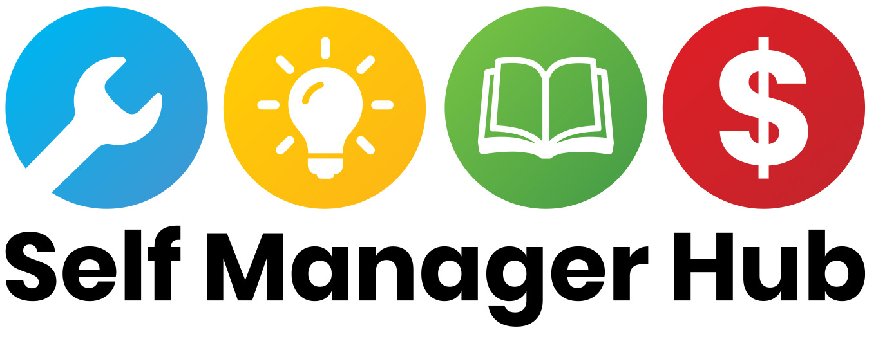

### Position Description

**Position Title:** Digital and Administrative Support Officer

**Organisation:** Self Manager Hub

**Award Classification:** SCHADS Award – Level 4

**Employment Type:** Casual / Part-time 15 hours per week (Negotiable)

**Reports To:** CEO

**Location:** Remote

### 1. Position Purpose

The Digital and Administrative Support Officer plays a vital role in supporting the operations of the Self Manager Hub. This position provides administrative, communications, and project support to ensure the smooth functioning of day-to-day activities and the successful delivery of our initiatives. The role includes managing information, coordinating assisting with event and project logistics, and maintaining our digital presence through website, social media, and accessible video content.

### 2. Key Responsibilities

**Administrative Support**

* Maintain digital filing systems, ensuring documents are well-organised, securely stored, and easily accessible to team members as needed.
* Provide secretarial support to the CEO and Board, including preparing agendas, taking meeting minutes, and tracking actions.
* Maintain accurate records and documentation for projects and organisational reporting.
* Assist with budget tracking and procurement of supplies and services.
* Respond to general enquiries received via email, through the website, or on social media platforms, ensuring timely and appropriate follow-up or escalation where required.

**Communications and Digital Presence**

* Assist with drafting, proofreading, and distributing newsletters, reports, and other communications materials, ensuring they are clear, accurate, and free of errors.
* Maintain and update website content, including uploading new resources, event listings, and news items.
* Monitor website to ensure content is accurate, accessible, and up-to-date.
* Schedule and monitor social media posts across platforms such as Facebook and LinkedIn.
* Respond to basic social media messages and comments or escalate when needed.
* Use Canva to create eye-catching and clear communications, including social media graphics, and other visual content.
* Support consistent branding and tone across all communications.

**Multimedia and Accessibility**

* Perform basic video editing (e.g., trimming, adding intros/outros, overlaying text).
* Add accurate captions to videos to ensure accessibility for all users.
* Assist with the preparation and publication of short videos for workshops, social media, or online learning.
* Arrange live captioners and Auslan interpreters as required.

**Event and Workshop Support**

* Assist in the coordination and logistics of online events, workshops, and meetings.
* Maintain participant lists, send reminders and follow-up emails.
* Help prepare event materials and evaluation surveys.

**Data and Reporting**

* Collect and collate data for reporting and evaluation purposes.
* Ensure privacy and confidentiality of Self Manager Hub data and subscribers.
* Maintain and update internal databases.
* Assist in preparing progress reports and summaries.

### 4. Key Performance Indicators:

* **Administrative Efficiency:** Complete scheduling, document management, and support tasks within agreed timeframes.
* **Meeting Support:** Provide timely and accurate Board and team meeting minutes and action tracking.
* **Event Support:** Provide administrative and technical support to workshops and peer support groups, with minimal disruptions.
* **Website Maintenance:** Ensure that website content is reviewed and updated regularly.
* **Social Media Engagement:** Maintain a regular posting schedule (minimum twice per week), with steady growth in engagement metrics such as reach, likes, and shares.
* **Video Accessibility:** Ensure all video content published by the Hub includes captions and is edited to a professional standard, with user feedback confirming accessibility and quality.
* **Communication Support:** Assist with regular communications (e.g., newsletters) and contribute to consistent engagement rates.
* **Data Accuracy:** Maintain up-to-date and accurate administrative records

### 5. Selection Criteria

**Essential**

* Experience in an administrative support, digital communications, or office coordination role.
* Strong organisational and time management skills.
* Excellent written and verbal communication abilities.
* Experience updating websites and scheduling content on social media platforms.
* Ability to perform basic video editing and captioning.
* Experience using Canva or similar tools to produce professional and engaging graphics.
* Proficiency with digital tools such as Microsoft Office 365, Zoom, and social media management tools.
* Understanding of or willingness to learn about the National Disability Insurance Scheme (NDIS) and self-management of NDIS funding.
* Ability to work independently and manage competing priorities.

**Desirable**

* Experience supporting projects, events, or communications.
* Familiarity with website platforms such as WordPress and Squarespace.
* Lived experience of disability.